**ACI Assignment 2**

**Group - 003**

**Question Q-2**

**Part 1: Constraint Satisfaction Problem:**

**Problem statement: Airport Flight Scheduler**

In an airport management portal, an AI agent is built to prepare an auto schedule for the below Jet-Airways flights take off time among the four available slots: 06:00AM IST, 07:00AM IST, 08:00AM IST, 09:00AM IST.  
Flight numbers: J-9W4569, J-9W377, J-9W4331, J-9W601, J-9W665.

Some of the operational inter-flight implicit binary constraints are given below:

J-9W4331 and J-9W4569 can start at the same time. C = A  
J-9W4331 and J-9W601 can start at the same time. C = D  
J-9W4331 and J-9W377 can start at the same time. C = B

J-9W4331 should start any time after the takeoff of J-9W665. C > E  
J-9W4331 should take off exactly one hour after the J-9W601 C = D +1  
J-9W665 should start any time before the takeoff of J-9W601 E < D  
J-9W4569 should start any time after the takeoff of J-9W601 A > D  
J-9W4569 may take off at the same time or any time before flight J-9W377 A <=B

E<D<C<A<=B

**In case of any multiple constraints for same set of variables, all the constraints must be satisfied. If there are any contradictory constraints, state the same explicitly in the answer and choose one with your justification.**

1. Draw the constraint satisfaction graph to represent this problem.
2. Implement Python code for the design under part a, using DFS with

Backtracking and heuristics including MCV and MRV.

1. Print the Flight wise scheduling details.

**Solution**:

Variables: Flight numbers: J-9W4569, J-9W377, J-9W4331, J-9W601, J-9W665 are denoted as A, B, C, D, E respectively.

Domains: A tuple time slot ∈ {1, 2, 3, 4} which indicates flights take off time among the four available slots: 06:00AM IST, 07:00AM IST, 08:00AM IST, 09:00AM IST and denoted as:

SixAM_Slot = 1

SevenAMS_lot = 2

EightAM_Slot = 3

NineAM_Slot = 4

Constraints:

J-9W4331 and J-9W4569 can start at the same time. C = A  
J-9W4331 and J-9W601 can start at the same time. C = D  
J-9W4331 and J-9W377 can start at the same time. C = B

J-9W4331 should start any time after the takeoff of J-9W665. C > E  
J-9W4331 should take off exactly one hour after the J-9W601 C = D +1  
J-9W665 should start any time before the takeoff of J-9W601 E < D  
J-9W4569 should start any time after the takeoff of J-9W601 A > D  
J-9W4569 may take off at the same time or any time before flight J-9W377 A <=B

C=A

C=D

C=B

Therefore, A = B =C = D

C[1] > E[1]

C[1] > D[1] + 1

E[1] < D[1]

A[1] > D[1]

A[1] <= B[1]

Therefore, E<D<C<A<=B

Note here we use C[1] to denote the third value of the tuple assigned to variable C. the time slot value, which is a number in {1, 2, 3, 4}

Enforcing arc consistency with MRV, we have the following domain as a result:

|  |  |  |  |  |
| --- | --- | --- | --- | --- |
| A | 1 | 2 | 3 | 4 |
| B | 1 | 2 | 3 | 4 |
| C | 1 | 2 | 3 | 4 |
| D | 1 | 2 | 3 | 4 |
| E | 1 | 2 | 3 | 4 |

(explanation of process below)  
Enforcing unary constraints (in an arbitrary order) first,

1. We crossout 2,3,4 from E’s domain, adding arcs E→D to the queue.

2. We crossout 1,3,4 from D’s domain, adding arcs D→C to the queue.

3. We crossout 1,2, 4 from C’s domain, adding arcs C→B and C→A to the queue.

4. We crossout 1,2, 3 from B’s and A’s domain, adding arcs B→A and A→B to the queue.

Note: For a general binary CSP, to enforce arc consistency before assigning any variables, we should add all arcs to the initial queue. For this problem, it can be easily seen that if there are no unary constraints, all the arcs will be consistent before any variable is assigned a value. As a result, we can start with the unary constraints and add arcs only for the related variables after enforcing the unary constraints.

**Constraint Graph:**

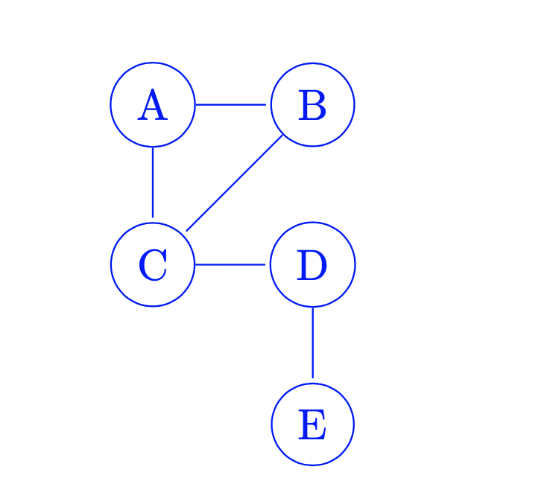

Explanation of Constraints Graph:

We can now encode the runway information into the identity of the variable, since the runway has more than enough time slots for the planes it serves. We represent the non-colliding time slot constraint as a binary constraint between the planes that use the same runways.